Enhancing Software Defect Prediction Using Explainable AI and Data Transformation
Priyanshu Kumar^{1†}, Kumar Rajnish^{2†}, Shubham Kumar^{3*†}
¹Department of Chemical Engineering, Birla Institute of Technology, Mesra, Ranchi, 835215, Jharkhand, India.
²Department of Computer Science and Engineering, Birla Institute of Technology, Mesra, Ranchi, 835215, Jharkhand, India.
³Department of Chemical Engineering, Birla Institute of Technology, Mesra, Ranchi, 835215, Jharkhand, India.

*Corresponding author(s). E-mail(s): btech10945.23@bitmesra.ac.in; Contributing authors: btech10950.23@bitmesra.ac.in; krajnish@bitmesra.ac.in;
†These authors contributed equally to this work.

Abstract
The rapid deployment of software in automation and the cognitive skills of machines indicate a machine revolution in modern human civilization. Still, predicting software flaws remains a significant challenge in ensuring software dependability and quality. The usefulness of incorporating Explainable Artifi- cial Intelligence (XAI) methods into the conventional Software Defect Prediction (SDP) pipeline to improve model performance and interpretability is examined in this study. In this paper, we took 5 publicly available datasets provided by Marco D’Ambros, Michele Lanza, Romain Robbes. We started with a thor- ough correlation analysis, identifying the top five characteristics that had the strongest correlation with the ”bugs” outcome variable. Followed by multiple pre-processing steps, these six-feature datasets (five predictors and one label) was then used to train and evaluate different classification models. Based on standard evaluation metrics, the two best-performing models were selected for a deep dive into local interpretability using Local Interpretable Model-agnostic Explanations (LIME). Following this, the best-performing model was subjected to global interpretability analysis using SHAPley Additive explanations (SHAP). The core contribution of this work lies in using the global feature impor- tance scores derived from SHAP values. A weighted average of these SHAP scores was calculated and applied to the remaining two datasets, generating two
new, ’SHAP-enhanced’ datasets. When the original classification models were re-evaluated on these new datasets, the results shows that the models trained on the ’SHAP-enhanced data’ show more stable and competitive results across unseen software projects.
Keywords: Software Defect Prediction, Explainable AI, Shap, Lime

Introduction
Software defect prediction (SDP) has been in use for a long time recognized as a crucial technique for improving software quality, reducing maintenance costs, and optimizing testing effort by identifying defect prone modules early in the development lifecycle [8]. Large-scale empirical studies have shown that a relatively small subset of soft- ware components often contains the majority of defects, making predictive modeling an effective strategy for resource allocation in quality assurance [6]. Over the years, researchers have used various types of software metrics including size, complexity, change, and object-oriented metrics to train machine learning classifiers for predicting defective software components [5][7].
With the availability of numerous datasets such as the PROMISE repository and Defects4J, defect prediction research has gained popularity in terms of reproducibility and standardization, enabling fair comparisons across different techniques and models [9][10]. These datasets contain the information about various metrics extracted from real-world software projects and have become the backbone of empirical SDP research. However, there are still many challenges related to data quality, imbalance, and reli- ability of some commonly used datasets, especially the NASA Metrics Data Program (MDP) datasets [35][36]. This indicates a need not only for better models but also for more efficient exploitation of the available data.
In recent years, many advanced machine learning methods such as Random Forests, Support Vector Machines, and gradient boosting algorithms have shown great per- formance in SDP tasks [28][29][30]. However, these models are often treated as black boxes, providing high predictive accuracy but very minimal insight into how decisions are being made. This lack of transparency creates a trust barrier for the researchers
, who prefer interpretable and actionable insights over purely numeric predictions [3][18].
Explainable Artificial Intelligence (XAI) provides an effective approach to this issue by clarifying the internal logic of the models for human understanding [1][2]. Some of the most commonly utilized XAI methods include Local Interpretable Model- agnostic Explanations (LIME) and SHAPley Additive Explanations (SHAP). LIME offers explanations at the instance level by locally approximating black-box models with interpretable surrogate models [1], whereas SHAP employs cooperative game theory for consistent and theoretically sound global and local feature attributions [2]. These techniques have been progressively utilized in areas like healthcare, finance, and more recently, software engineering [18][21].
Many recent studies have explored the application of XAI in software defect pre- diction, primarily focusing on improving model transparency and researchers trust [19][20][21]. However, most of these works treat explainability as a post processing analysis layer, rather than exploiting XAI outputs to further improve the predictive performance of defect prediction models. Shin et al. argued that while explainable SDP has gained attention, there remains a lack of methods that transform explanations into actionable improvements in the existing modeling pipeline itself [18].
Parallel to this, feature selection and dimensionality reduction have been shown to significantly affect the performance of SDP models. Xu et al. demonstrated that careful feature selection can lead to improved accuracy and reduced overfitting in defect pre- diction tasks [23]. Traditional feature selection techniques rely on correlation analysis, information gain, or wrapper based selection methods. However, these approaches do not take into account how features contribute to model decisions in complex nonlinear learners.
This research bridges this gap by leveraging SHAP based global feature importance scores to construct feature weighted datasets. Using SHAP values derived from the best performing model, we generate a weighted representation of features and use it to transform two subsets of the original dataset. This transforms explainability into an active component of the learning process rather than a passive diagnostic tool. Similar ideas of using explanation mechanisms to guide model improvement have recently gained traction in machine learning research but remain underexplored in the domain of software defect prediction [37][51].
Our work therefore contributes to the growing intersection of XAI and SDP by proposing a research , evidence driven pipeline where explanations directly enhance predictive performance. By integrating correlation based filtering, multi-model eval- uation, LIME based local interpretability, and SHAP based global weighting, this study demonstrates a principled approach to building both accurate and explainable defect prediction systems, aligned with rising calls for practical and trustworthy AI in software engineering [18][50].

Related Works in the field of SDP
Software defect prediction (SDP) is a well-established research area within software quality assurance and automated software analytics. Over the last few decades, many studies have explored the use of static code metrics, machine learning, and recently deep learning was aslo used to determine defect proneness in software systems. Sev- eral comprehensive studies have shown the development of this field and highlight its continued relevance in modern software engineering environments [8][29][30]. These surveys prove that as the scale of the software grows, predictive models play a huge role in intercepting defects and minimizing the cost and operations.
A large number of classical work has focused on designing and evaluating metric- based bug prediction models. Early foundational studies demonstrated that structural code attributes such as complexity, size, coupling, and cohesion shows strong signs of defective modules [5][6][7]. Public datasets such as those in the PROMISE repos- itory [10] and Defects4J [9] have enabled standardized benchmarking, which in turn
accelerated progress by making empirical evaluations reproducible. However, multi- ple analyses have raised concerns about the quality and consistency of older datasets, especially NASA MDP, pointing to mislabeled instances, preprocessing inconsistencies, and noise that can distort model evaluation [35][36]. This has motivated the com- munity toward deeper data preprocessing, better feature screening, and more robust model evaluation practices.
Following advancements in machine learning, a wide range of classifiers Random Forests [22], Support Vector Machines [24], and gradient boosting methods such as XGBoost [23] have been applied to defect prediction with considerable success. Many studies have shown us that ensemble learners often outperform traditional learners due to their ability to capture nonlinear instances [31][32]. In recent times, deep learning models have also been used for SDP [27][41], although their use is still limited due to their data requirements.

Methodogoly

Research question goals
In this paper, we’d like to propose, comparing multiple ML models for software defect prediction. Our primary goal is to determine whether the model’s results change after applying SHAP weights to generalise the dataset and make it more interpretable. For that, we want to comprehend both local and global explanations and answer the following research questions(RQ).
RQ1: Which ML models show the most robust performance for software defect prediction on multiple projects?
RQ2: Among the top baseline models, which model provides the best result for the local interpretation using LIME?
RQ3: How does SHAP-driven feature importance influence the overall result of the model performances?

Proposed Architecture of the SDP Model
The fig 1 depicts the complete workflow of the proposed Explainable AI driven SDP framework. It begins with data acquisition and preprocessing, including imbal- ance handling and feature diagnostics, followed by training multiple machine learning models.The local interpretation was performed using LIME and SHAP for global explanations. SHAP-derived feature importance is further leveraged to construct SHAP-weighted datasets for cross-project evaluation. Finally, model performance is compared across original and SHAP-enhanced datasets to assess the impact of explainability on predictive effectiveness.

Dataset Description
In this study we have used 5 bug prediction dataset.The bug prediction dataset is a collection of models and metrics of software systems and their histories. The goal of such a dataset is to allow people to compare different bug prediction approaches
Table 1 Contributions and Limitations of Different Studies in the Literature

Ref Contribution Limitation
[14]
Shin
et al., 2021

[15]
Haldar et al., 2023

[16]
Zheng et al., 2022

[17]
Schulte et al., 2024

[18] Al-
Smadi et al., 2023

[50]
Haldar, 2024

[51]
Haldar et al., 2023

[59]
Zheng et al., 2022 (JIT- LIME)
Provided one of the first systematic evaluations of XAI methods (LIME, SHAP) for software defect prediction. Demonstrated how explanations influ- ence developer trust and revealed mismatches between model accuracy and explanation stability, raising foundational questions about XAI reliabil- ity in software engineering.
Analyzed explanation stability across models and datasets in defect prediction. Introduced quanti- tative metrics for measuring robustness and high- lighted vulnerabilities in explanation consistency, particularly in cross-project settings.
Applied LIME to Just-in-Time defect prediction at the commit level. Offered fine-grained inter- pretability by identifying which code-change fea- tures triggered buggy predictions, enhancing prac- tical usefulness for developers.
Compared LIME and SHAP explanations for issue prediction tasks. Identified systematic biases in explanations and assessed consistency across mod- els, highlighting scenarios where developers should or should not rely on XAI outputs.
Applied SHAP to defect prediction tasks to uncover global feature importance patterns. Demonstrated how SHAP reveals insights beyond traditional correlation metrics, identifying mis- leading features and model weaknesses.
Proposed interpretable models using effort-based features, emphasizing simplicity and transparency while maintaining competitive accuracy. Demon- strated effective integration of domain knowledge with interpretable machine learning.
Provided a deep critical analysis of XAI behav- ior in software defect prediction, revealing mis- matches between global and local explanations and clarifying how explanation inconsistencies arise in practice.
Demonstrated LIME’s practical utility in indus- trial environments for commit-level bug predic- tion. Showed how explanations help developers understand prediction outcomes and improve code quality processes.
Explanations were not used to improve model performance; the study remained diagnostic. Eval- uation was limited to a small set of datasets and did not integrate XAI outputs back into the learn- ing pipeline.

No mitigation strategies were proposed for unsta- ble explanations. Experiments relied on limited datasets, reducing generalizability, and the study focused on evaluation rather than constructive interpretability.
Only local explanations (LIME) were explored, with no global interpretability (SHAP). Explana- tions were not used to improve training data or models, and the work focused exclusively on JIT prediction, limiting general SDP applicability.
Evaluation was not SDP-specific, as issue predic- tion differs from defect prediction. Dataset scale was small, limiting external validity, and explana- tions were not incorporated into model improve- ment.
Explanations were purely diagnostic and not used to build improved datasets or models. Limited dataset variety and model diversity reduce the strength of conclusions.

Did not employ modern XAI methods (SHAP, LIME), limiting interpretability granularity. The approach focused specifically on effort metrics and is not generalizable to complexity or process met- rics.
Offered no constructive method for reducing or correcting explanation inconsistency. Did not explore the use of XAI for model enhancement, remaining analytical rather than methodological.

Limited to local explanations only, with no SHAP or hybrid interpretability. Explanations did not influence model improvement and were restricted to JIT-level data, not module-level SDP.

and to evaluate whether a new technique is an improvement over existing ones. In particular, the dataset contains the data needed to:
- run a prediction technique based on source code metrics and/or historical measures and/or process information (cvs logs data);
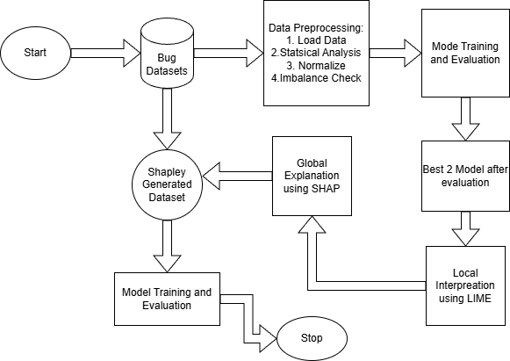

Fig. 1 Flowsheet showcasing proposed methodology

- compute the performance of the prediction by comparing its results with an oracle set, i.e., the number post release defects reported in bug tracking system.
The dataset is designed to perform bug prediction at the class level. However package or subsystem information can be derived by aggregating class data, since per each class it is specified the package that contains it.

Table 2 Details of Datasets

Dataset Name | Rows | Columns
Eclipse JDT Bug Metrics | 997 | 12
Equinox Framework Bug Metrics | 324 | 12
Lucene Bug Metrics | 691 | 12
Mylyn Bug Metrics | 1862 | 12
Eclipse PDE Bug Metrics | 1497 | 12

Pre-Processing
The three primary datasets (Eclipse JDT, Equinox, and Lucene), were taken for the initial pre-processing pipeline to standardise the three datasets and maintain com- patibility across the project. Initially, the raw bug metric datasets were cleaned by removing non-numeric features, followed by handling of missing values. The target variable is set up in a way that it tells whether the class is buggy or not, enabling a perfect classification setup. Class distribution was examined to assess imbalance before to model training. Multi-collinearity among software metrics was analysed using Variance Inflation Factor (VIF), and dimensional dependencies were further studied through Principal Component Analysis (PCA) without discarding original features, allowing statistical analysis of correlated structures. To address the highly skewed and zero-inflated nature of defect-related metrics, logarithmic and Yeo–Johnson trans- formations were applied, and their effects were validated through before-and-after skewness analysis. Finally, both Pearson and Spearman correlation analyses were con- ducted to identify the most informative predictors, resulting in a reduced feature set that preserved interpretability while supporting effective downstream modelling.

Variance Inflation Factor Analysis
The software defect datasets are well known to suffer from high multi-collinearity among software metrics, particularly the once with cumulative and historical bug- related features. Multi-collinearity can increase variance in the parameter estimates. To examine this issue, Variance Inflation Factor analysis was conducted on the three primary datasets Eclipse, Equinox, and Lucene before feature selection and model training.
The VIF tells us about the quantification of the relation of variance among the fea- tures. A VIF value greater than 10 typically indicates severe multicollinearity, while values between 5 and 10 suggest moderate correlation among the features. The results shown in Table 3 clearly reveal that cumulative bug count metrics, such as NBFU and NNTBFU, exhibit very high VIF values across projects, confirming strong linear dependencies among these historical metrics. This behaviour is expected, as these fea- tures are derived from overlapping bug histories and naturally co-exist during software development.
In contrast, instantaneous defect indicators such as MB, CB and NTB consistently showed low VIF values, indicating relatively independent and more stable.
Rather than discarding highly collinear features outright, the study retained them for further statistical analysis and applied Principal Component Analysis (PCA) to study correlated structures while preserving the original feature space for interpretabil- ity. This strategy enabled a principled balance between statistical robustness and explainability, which is critical in defect prediction research.

SMOTE Resampling Technique
Similar to multi-colinearity hte SDP datasets also suffer from imbalanced classes, the bug ratio in bug databases is less indicating a significant imbalance. Frequently, bug models that are trained on datasets with class imbalances yield imprecise results.
Table 3 Summary of Variance Inflation Factor (VIF) Results Across Projects

Feature Name | Equinox VIF | Eclipse VIF | Lucene VIF
NBFU | 265.51 | 211.45 | Very high multicollinearity (≫
NNTBFU | 262.15 | 236.55 | 10)  Very high multicollinearity (≫
 |  |  | 10)
NMBFU | 7.03 | 11.47 | Moderate to high multi-
 |  |  | collinearity
NCBFU | 4.30 | 5.15 | Moderate multicollinearity
MB | 1.40 | 2.15 | Low multicollinearity
CB | 1.35 | 1.86 | Low multicollinearity
NTB | 1.00 | 1.24 | Low multicollinearity

Table 4 Abbreviation List for Bug-Metrics Dataset Features

Abbreviation Full Feature Name
NBFU numberOfBugsFoundUntil
NNTBFU numberOfNonTrivialBugsFoundUntil
NMBFU numberOfMajorBugsFoundUntil
NCBFU numberOfCriticalBugsFoundUntil
NHPBFU numberOfHighPriorityBugsFoundUntil
NTB nonTrivialBugs
MB majorBugs
CB criticalBugs
HPB highPriorityBugs
BUG bugs

Therefore, we apply SMOTE to increase the number of instances in the dataset in a balanced way to improve predictive accuracy. Here’s how the SMOTE algorithm functions:
      - First, select a random sample of the minority group’s members.
      - Next, determine which k nearest neighbors each observation in this sample belongs to.
      - One of those neighbors should then be used to compute the vector between the current data point and the chosen neighbor.
      - The vector is multiplied by a randomly selected integer between 0 and 1.
      - Next, this will be added to the current data point to create the synthetic data point.

Data Standarization
Software defect datasets generally consists of features with different magnitudes and measurement scales, feature standardization is applied to ensure that no sin- gle attribute disorient the training process. In this study. It is applied through the ”StandardScaler” implementation in the scikit-learn library. Standardization trans- forms each feature to have a mean of zero and a standard deviation of one, therefore
Table 5 Class Distribution Before and After SMOTE

Dataset | Stage | No-Bug | Bug | Imbalance  Ratio (0/1)
Eclipse | Before SMOTE | 791 | 206 | 3.84
Eclipse | After SMOTE | 791 | 791 | 1.00
Equinox | Original (No SMOTE) | 195 | 129 | 1.51
Lucene | Before SMOTE | 627 | 64 | 9.80
Lucene | After SMOTE | 627 | 627 | 1.00

preserving the relative distribution of values while enabling fair distance computation and faster convergence for our distance-based classifiers.
The Z-score standardization is determined using:

_{X}std ₌ Xi − µi

(1)
i _{σi}
where X^{std} represents the standardized value of the i-th feature.
i

Base-Line ML Models
To determine the effectiveness of our proposed explainability-guided defect prediction framework, this study we used seven widely used machine learning classifiers that are commonly adopted in software defect prediction literature. These models include Logistic Regression(LR), Support Vector Machine with RBF kernel(SVM), k-Nearest Neighbours(KNN), Decision Tree(DT), Random Forest(RF), Gradient Boosting(GB), and Extreme Gradient Boosting(XGBoost). The dollowing models are selected to rep- resent the diverse nature of the learning curve, including linear, non-linear, tree-based, ensemble and boosting.
For all the above baseline models, they were split into training and testing sets using the sklearn class of train_test_split to ensure the class distribution among the test and train sets. Feature scaling and pre-processing were applied before the model training, and class imbalance was handled using resampling techniques. In the case of the KNN classifier, preliminary experiments were conducted to identify an appropriate value of k by analyzing the performance of the model in different neighbourhood sizes, and the value that produced the most stable performance was selected for the future evaluation.
The performance of all these models was assessed using standard classification metrics, which include Accuracy, Precision, Recall, F1-score, and Receiver Operating Characteristic Area Under the Curve(ROC-AUC). Among these, ROC-AUC was more given most preference due to its versatile nature in the presence of class imbalance. ROC-AUC estimates the probability that a classifier ranks a randomly selected defec- tive instance higher than a randomly selected non-defective instance. In this study’s context the class 0 represents the non-buggy class, while the class 1 means the soft- ware is buggy. Additionally, the F1-score is defined as the harmonic mean of precision and recall and was used to provide a balanced measure of predictive performance, especially for the imbalanced dataset.
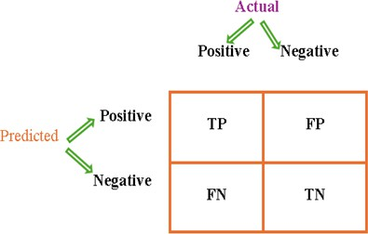

Fig. 2 Confusion matrix for classification models

Evaluation Metrics
Model assessment is a multi-step process that employs metrics to analyze the model’s performance. It is important to monitor the model’s ability to generalize future pre- dictions. As a result, model evaluation is essential to determining how well proposed and current machine learning model’s function. The assessment aids in the analysis of a model’s main flaws as well. In this study, we assess the accuracy, precision, recall, F1-measure, and ROC-AUC score of the proposed and current models. In machine learning, a confusion matrix—also known as an error matrix—is employed in the statistical classification problem. A confusion matrix is a summary of the results of classification problem prediction. Using count values, the total number of correct and incorrect predictions is divided by class. The confusion matrix illustrates how a clas- sification model might get perplexed while making predictions in a variety of ways. It makes the type and amount of classification errors clear. Fig. 2 depicts a description of the confusion matrix. Instances that are no-bug are labeled ”negative,” and those that are bug are labeled ”positive.”
Some terms in the matrix are as follows:
- True Positives: This is also known as TP. It is an output in which both the actual and projected values are positive.
- True Negatives: Also known as TN. It is an output in which both the actual and anticipated values are negative.
- False positives: It’s also known as FP. It is the output in which the true value is negative, but the forecasted value is positive.
- False Negatives: Also known as FN. It is an output with a positive actual value but a negative anticipated value.
The additional assessment parameters descriptions are as follows:
- Accuracy: The most fundamental statistic used to assess the model is accuracy, which may be defined as the ratio of correct predictions to total predictions. The formula for this is accuracy = (TP+TN)/(TP+TN+FP+FN).
- Precision: Precision is a statistical measure of the accuracy of positive predictions, expressed as precision = TP/(TP+FP), which is the ratio of true positives to the sum of true positives and false positives.
- Recall: The ratio of genuine positives to the total of false negatives and true pos- itives is known as recall. In essence, it examines how many accurate positive samples there are. Recall is equal to TP divided by (TP+FN).
- F1-Score: The harmonic mean of recall and precision is the F1 score. It has been observed that in the accuracy-recall trade-off, recall falls when precision rises and vice versa. The F1 score aims to balance recall and precision. F1 score is equal to (2×Recall×Precision)/(Recall+Precision).
- ROC-AUC Curve: An assessment statistic called AUC (Area Under Curve) is used to examine the classification model at various threshold settings. A probabilistic curve called the Receiver Operating Characteristic (ROC) curve is used to illustrate how well the model performs. There are two parameters on the curve: (i) TPR: True positive rate and essentially uses the Recall formula. (ii) FPR: False Positive Rate and it is the ratio of false positives to the total of false positives and true negatives how it is defined. This curve is helpful because it allows us to assess how well the model can differentiate between various classes. An effective statistic for assessing the model is the AUC score. It essentially draws attention to a model’s ability to divide classes. When a model’s AUC value is higher than 0.5 and getting closer to 1, it is deemed good. An AUC score of 0 indicates an unacceptable model.

Model Agnostic Techniques
Model Agnostic Techniques have been used in order to improve the performance of the existing baseline models by enhancing their comprehension of the underlying rea- soning processes employed by these systems. It can potentially serve as a practical appearance of the social superiority to explanation. It provides transparency and comprehension of the decision making processes of the underlying AI system. XAI endeavors to comprehensively explain past, ongoing, and future actions and the under- lying information upon which these actions are predicated. Additionally, it can help understand a model’s behavior and create faith in the model itself.

Local Interpretability Model Agnostic Explanation
Local Interpretable Model-agnostic Explanations (LIME) is a model-agnostic tech- nique designed to explain individual predictions of any machine-learning model regardless of its architecture or internal assumptions. Because LIME operates inde- pendently of the learner, it can clarify predictions from black-box methods by approximating the model’s decision surface locally with an interpretable surrogate (for example, a sparse linear model or a shallow decision tree). Concretely, LIME con- structs a neighbourhood around the instance of interest by perturbing the input and generating a synthetic dataset that is locally faithful to the original sample. A simple
interpretable model is then fitted to the synthetic data and the coefficients (or rule weights) of this surrogate are used to identify and rank the most influential features for that instance. The result is a human-readable, instance-level explanation that reports which attributes increased or decreased the predicted probability for the target class. This local focus makes LIME particularly valuable for understanding why a complex classifier produced a given decision while highlighting that these explanations are valid only in the local neighbourhood of the explained instance.

Workflow for LIME’s Local Explanation

Initialization of the LIME Explainer
A ”LimeTabularExplainer” was initialized using the training data(X_train), with the mode set to classification. The class labels were explicitly defined as Bugs and No-Bugs.

Definition of the Prediction Probability Wrapper
LIME requires class probability estimates, a custom prediction wrapper function was defined. This function invokes the classifier’s probability of the prediction method and returns the probabilities for both buggy and non-buggy classes.

Selection of Test Instances
Individual instances were randomly selected from the test dataset (X_test) for explanation.Using x = random.randInt(0, len(X test))

Generation of Local Explanations
The explain_instance() function of the LIME explainer was called to generate the final instances.

Visualization and Interpretation
The resulting explanations were highlighted using the matplotlib and seabborn libraries.

SHapley Additive exPlanations (SHAP)
The SHAP approach is applied to explain individual forecasts and make a prediction approach using the model for a specific instance. After that, the overall prediction is achieved by measuring the individual features. It computes shapely values derived from coalitional game theory, providing a method for equally distributing the predicted outcome among the various attributes. One advantage of SHAP is the representation of the shapley value explanation as an additional feature attribution technique, which can be conceptualised as a linear model.

Workflow for SHAP’s Global Explanation

Initilization of the SHAP explainer
The shap.Explainer() function was applied to the training dataset (X_{train}) to initialize the SHAP explainer, as shown below:
explainer = shap.Explainer(classifier, X_{train})

Computation of SHAP Values
shap values = explainer.shap values(X test), shap values were determined.

Global Summary Visualization
shap.summary plot(shap values, X test, feature names = X.columns). It was executed to generate the visualization of the shap values.

Aggregation of SHAP Values
Result = pd.DataFrame(shap values, columns = X.columns), The shap values that were obtained for each dataset was than aggregated and transported using a CSV file.

Feature Ranking based on Mean absolute SHAP Values
To get the feature ranking, the SHAP values were averaged across all the testing instances across all the features.

Results
Considering our three reserch questions following is our case study finding:

Pre Xai Analysis
RQ1:Which ML models show the most robust performance for software defect prediction on multiple projects?
Approch: To examine RQ1 we check the performance of various ML models on our bug metrics dataset, and the performance is analysed using various performance metrics.
- The results recorded in Tables 6–8 show that, all evaluated classifiers achived almost similar accuracy across the Eclipse, Equinox, and Lucene datasets but SVM (RBF) and XGBoost consistently demonstrate better overall performance when multiple eval- uation metrics are taken in account. In particular, SVM achieves the highest recall values across datasets, indicating a stronger ability to identify defect-prone module and reduce false negatives.
- On the other hand, XGBoost also records the highest or near highest ROC-AUC values, reflecting better discriminative capability in separating faulty and non-faulty instances across different decision thresholds. While some models perform competi- tively in isolated metrics, like logistic regression shows more stable performance across the 3 datasets, but performance varies across datasets. In contrast, SVM and XGBoost are more consistent.

Table 6 Pre-XAI Results on Eclipse JDT Dataset

Model | Accuracy | Precision | Recall | F1-score | ROC-AUC
Logistic Regression | 0.68 | 0.60 | 0.61 | 0.60 | 0.70
KNN | 0.71 | 0.65 | 0.62 | 0.63 | 0.71
Decision Tree | 0.70 | 0.62 | 0.64 | 0.63 | 0.71
Random Forest | 0.71 | 0.64 | 0.63 | 0.63 | 0.72
Gradient Boosting | 0.70 | 0.63 | 0.60 | 0.61 | 0.70
SVM (RBF) | 0.69 | 0.58 | 0.75 | 0.65 | 0.72
XGBoost | 0.72 | 0.66 | 0.64 | 0.65 | 0.73

Table 7 Pre-XAI Results on Equinox Framework Dataset

Model | Accuracy | Precision | Recall | F1-score | ROC-AUC
Logistic Regression | 0.69 | 0.61 | 0.63 | 0.62 | 0.71
KNN | 0.72 | 0.66 | 0.64 | 0.65 | 0.72
Decision Tree | 0.70 | 0.63 | 0.65 | 0.64 | 0.72
Random Forest | 0.71 | 0.64 | 0.62 | 0.63 | 0.72
Gradient Boosting | 0.70 | 0.62 | 0.61 | 0.61 | 0.71
SVM (RBF) | 0.68 | 0.57 | 0.74 | 0.64 | 0.71
XGBoost | 0.73 | 0.67 | 0.65 | 0.66 | 0.73

Table 8 Pre-XAI Results on Lucene Dataset

Model | Accuracy | Precision | Recall | F1-score | ROC-AUC
Logistic Regression | 0.67 | 0.60 | 0.62 | 0.61 | 0.70
KNN | 0.71 | 0.65 | 0.61 | 0.63 | 0.71
Decision Tree | 0.69 | 0.62 | 0.64 | 0.63 | 0.71
Random Forest | 0.70 | 0.63 | 0.62 | 0.62 | 0.72
Gradient Boosting | 0.69 | 0.62 | 0.60 | 0.61 | 0.70
SVM (RBF) | 0.66 | 0.55 | 0.76 | 0.64 | 0.71
XGBoost | 0.72 | 0.66 | 0.63 | 0.64 | 0.73

Even though SVM-RBF and XGBoost don’t dominate in the every single evalua- tion metric, but due to superior generalization across the datasets will be used in the further part of the explainability analysis.

LIME Explanations
RQ2: Among the top baseline models, which model provides the best result on the local interpretation using LIME?
Approch: For further explanation of the interpretability of the two best-performing classifiers identified in the pre-XAI analysis SVM (RBF) and XGBoost local expla- nations were generated using LIME for multiple test instances across the datasets. The comparison was focused on three key aspects: stability of explanations across instances, clarity of feature contributions, and consistency with domain intuition.
The LIME explanations (shown in the Fig. 3) produced for the SVM model exhib- ited noticeable randomness across instances, with frequent shifts in both the magnitude and direction of feature contributions. Even though SVM achieved strong predictive performance, its local explanations were often prone to small perturbations in the input space, resulting in less stable attribution patterns. This behavior is seemingly constant with the non-linear decision boundary of kernel-based methods, where local linear approximations may vary significantly across neighboring samples, resulting in poor performance in the local interpretation.
On the other hand , the LIME explanations generated for the XGBoost model (shown in Fig. 4) were more consistent across the multiple instances, repeatedly high- lighting the same subset of dominant metrics, such as cumulative bug counts and severity-related features, as primary contributors to defect prediction. The directional- ity of this feature influence (positive or negative contribution toward the “bug” class) remained stable across the multiple instances, improving interpretability and trust in the explanations. Additionally, the sparsity of the explanations and the clearer sepa- ration between supporting and opposing features made XGBoost’s decisions easier to reason in a software defect prediction.
Based on this comparative analysis between our two benchmark models, XGBoost was selected as the final model for global interpretability using SHAP. The combi- nation of strong predictive performance and more coherent, stable local explanations under LIME makes XGBoost a more suitable candidate for deriving reliable global fea- ture importance scores. These properties are essential for the subsequent SHAP-based analysis, where feature attributions are aggregated and transferred across datasets to construct SHAP-enhanced defect prediction models.
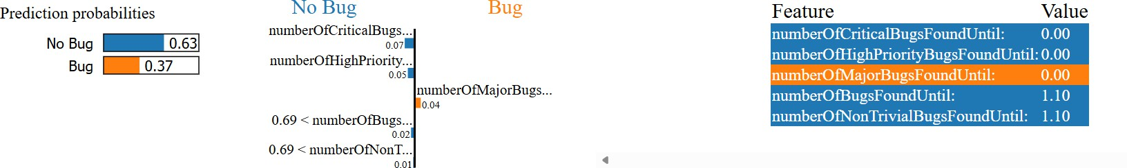
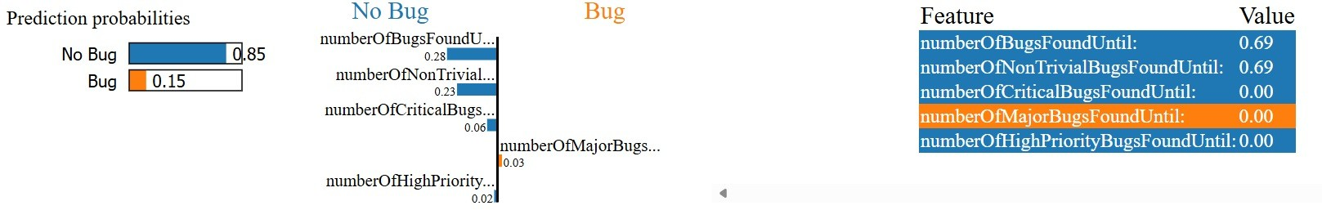
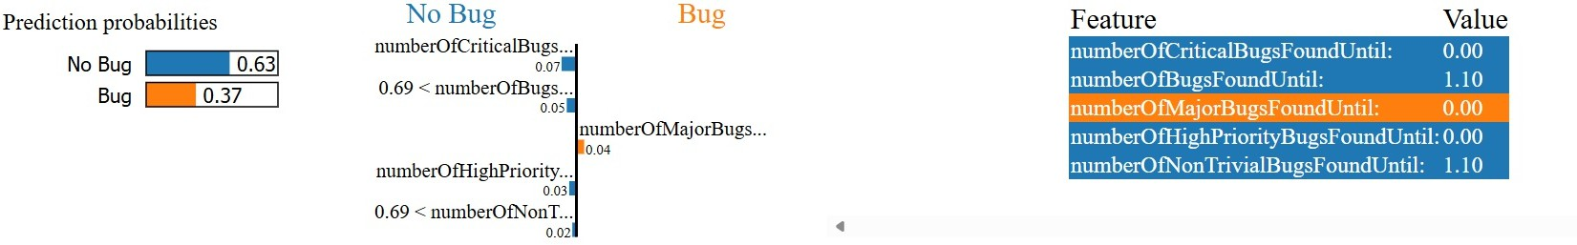

Fig. 3 SVM-RBF LIME Interpretation on Multiple Instances

SHAP Explanations
In this section, the Global Analysis of our best-performing model (XG-Boost) was done using SHAP(Summary plot in Fig. 5).
- The NBFU feature shows the highest mean absolute SHAP value, making it the most influential predictor for bug occurrence of the eciplse dataset. NNTBFU is the second most prominent feature and consistently contributes toward higher bug probability.In contrast, the severity-related features, such as MB, NMBFU, and
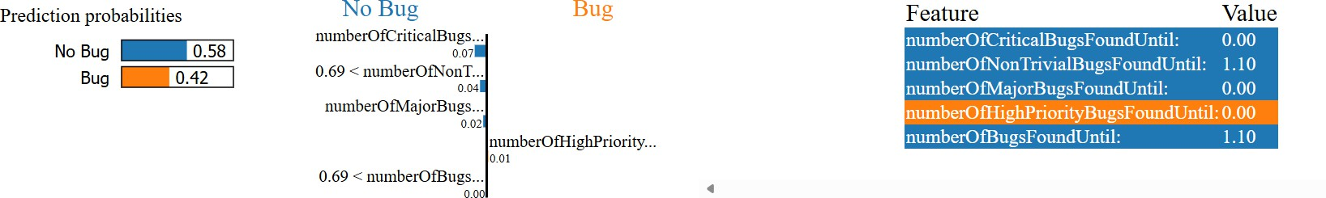
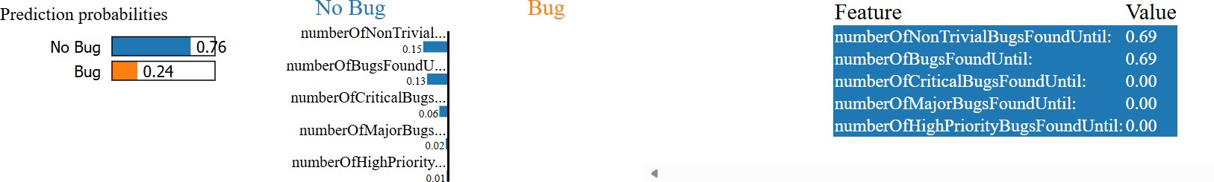
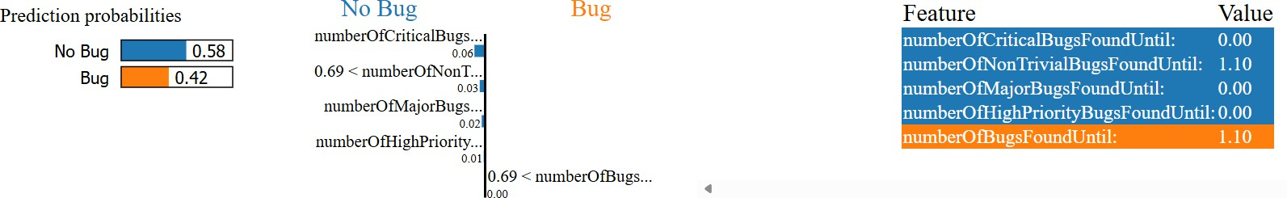

Fig. 4 XGBoost LIME Interpretation on Multiple Instances

NCBFU, have smaller but non-zero contributions. The SHAP summary plot indi- cates that higher historical bug counts strongly push model toward buggy class predictions. This confirms that the past defect accumulation is a major indicator in predicting future defects for Eclipse.
- However, in Equinox dataset NNTBFU was the most prominent indicator and NBFU emerged as the second-best feature influencing predictions. These features exhibit both high SHAP magnitude and consistent directional impact across mul- tiple instances.The other features contributed moderately to the prediction. The SHAP distribution also points that the cumulative bug history has a stronger effect than isolated severity-based metrics. This indicates that past bug behaviour is more informative than single category bug severity for Equinox dataset.
- As of the Lucene dataset, NBFU dominates the SHAP importance ranking, show- ing the strongest influence on the model output. Following the trend from the other two models. Severity-specific metrics show relatively smaller SHAP values(nearly 0). The SHAP summary plot clearly shows that higher values of cumulative bug fea- tures significantly increase the likelihood of defect prediction. This pattern confirms the consistency of bug-history-based predictors in Lucene.
- Across all the three datasets, the same core features were the highest ranked constanlty. This showcase that the cumulative freature over time are more promi- nent in the field of SDP and also the cross-generalization between the projects. This concludes that the results of the XGBoost results were meaningful and interpretable.
- Mean absolute SHAP values from all three datasets were calculated and averaged to obtain a unified feature importance vector for further use. This averaged SHAP vector represents the global importance of each feature across multiple projects. The averaged SHAP weights were then used to scale corresponding features in the
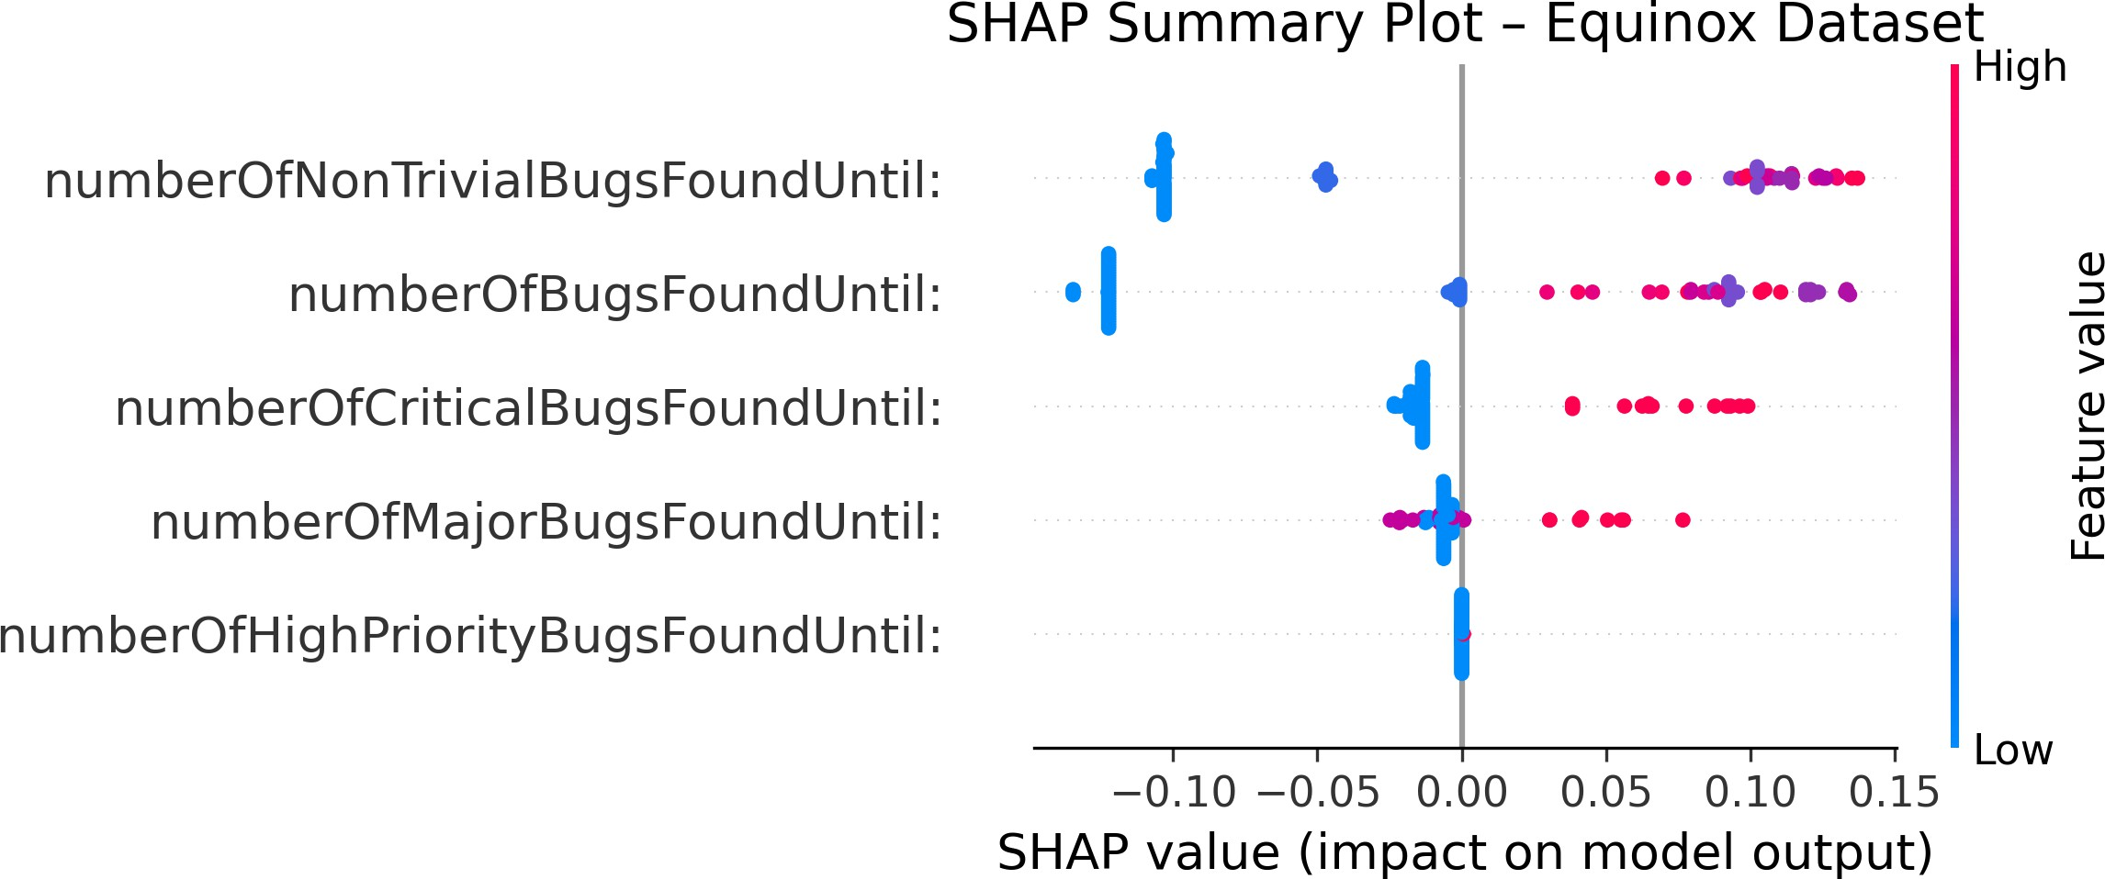
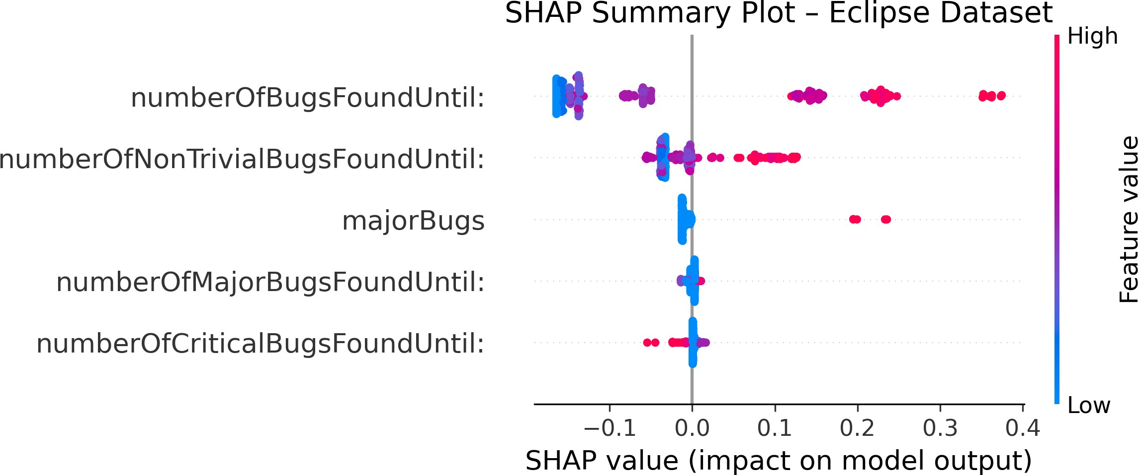
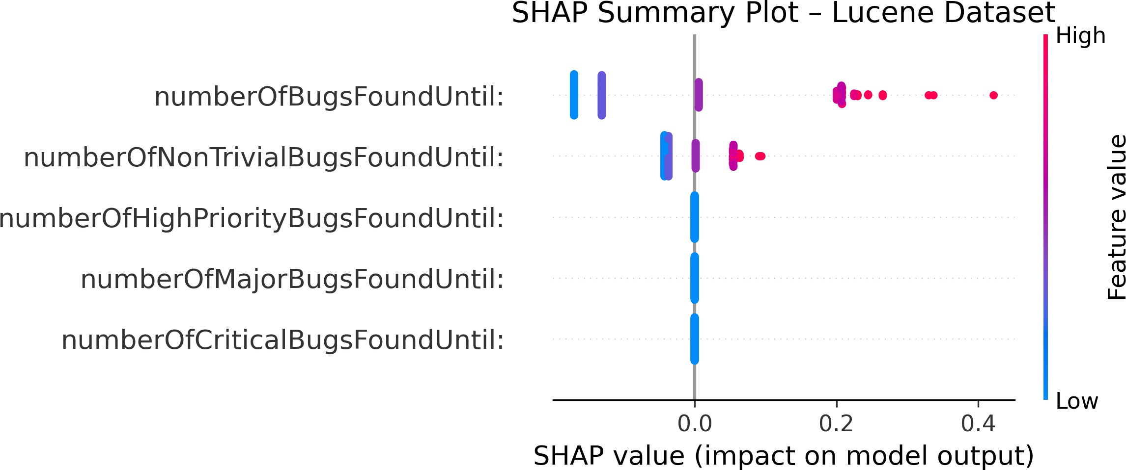

Fig. 5 Global SHAP Summary Plots
Mylyn and PDE datasets. This process preserves the original feature space while emphasising features with higher explanatory power. The resulting datasets are referred to as SHAP-weighted (SHAP-enhanced) datasets.

Shapely-Enhanced Datasets
The SHAP-enhanced datasets were constructed by utilizing the global feature impor- tance scores obtained from the SHAP (SHapley Additive exPlanations) analysis. Mean SHAP values were obtained by aggreagation of the SHAP values of individ- ual datapoints. These weights were then applied to the respective features of the target datasets(Mylyn and PDE) through feature wise multiplication, thereby empha- sizing metrics that consistently exhibited higher explanatory power across projects. This approach preserves the original feature information while embedding model- driven interpretability into the data representation, enabling a systematic evaluation of whether SHAP-informed feature weighting can improve defect prediction performance and generalization.

Model Evaluation on Shapely-Enhanced Datasets

Table 9 Performance of ML Models on SHAP-Enhanced Mylyn Dataset

Model | Accuracy | Precision | Recall | F1-score | ROC-AUC
Logistic Regression | 0.71 | 0.66 | 0.63 | 0.64 | 0.73
Decision Tree | 0.72 | 0.67 | 0.65 | 0.66 | 0.74
KNN | 0.73 | 0.69 | 0.66 | 0.67 | 0.75
Random Forest | 0.74 | 0.71 | 0.68 | 0.69 | 0.77
Gradient Boosting | 0.74 | 0.72 | 0.67 | 0.69 | 0.78
SVM (RBF) | 0.76 | 0.74 | 0.71 | 0.72 | 0.80
XGBoost | 0.77 | 0.75 | 0.72 | 0.73 | 0.81

Table 10 Performance of ML Models on SHAP-Enhanced Eclipse PDE Dataset

Model | Accuracy | Precision | Recall | F1-score | ROC-AUC
Logistic Regression | 0.70 | 0.64 | 0.61 | 0.62 | 0.72
Decision Tree | 0.71 | 0.66 | 0.63 | 0.64 | 0.73
KNN | 0.72 | 0.68 | 0.64 | 0.66 | 0.74
Random Forest | 0.74 | 0.70 | 0.67 | 0.68 | 0.77
Gradient Boosting | 0.75 | 0.71 | 0.68 | 0.69 | 0.78
SVM (RBF) | 0.76 | 0.73 | 0.70 | 0.71 | 0.79
XGBoost (SHAP-enh.) | 0.78 | 0.75 | 0.72 | 0.73 | 0.82

RQ3: How does SHAP-driven feature importance influences the overall result of the model performance?
Approach: All the original baseline models were retrained on the Shapley enhanced datasets to determine the answer for RQ3.
- The overall results on the Shapley-enhanced Mylyn and Eclipse PDE datasets show a consistent increase in the model evaluation and performance. This improvement in the performance can be supported by the SHAP-value generalisation, as the global SHAP values tend to increase the weightage of the historically accumulated bugs and decrease the dependency on the severity-based bugs. The SHAP value dataset improved generilazion leads to a decrease in noise of the dataset.
- Tables 9 and 10 show that the ensemble-based and margin-based classifiers, specif- ically XGBoost and SVM (RBF), benefit the most from this transformation done by global SHAP values. XGBoost utilises the reweighting of datasets to create a more meaningful structure during boosting iterations, resulting in improved F1 and ROC-AUC scores. Similarly, SVM also uses this feature modification for a better decision boundary, resulting in improved recall and balanced precision-recall trade- offs. These gains can directly correlate to the information gain with the addition of any complexity to the model.
- However, there small decile in some evaluation metrics, mainly precision. This could be due to the SHAP weights focusing more on determining the bug. In practice, this leads to a minor increase in the values of false negatives, resulting in the decline of the precision metric,but it simultaneously increases the model dependency on detecting the buggy class. In the defect prediction context, such a decline in the model performance is an acceptable trade-off.
- Furthermore, the tree-based learner decision tree classifier leveraged less compared to that of its other counterparts like SVM and XGboost. This might be due to the sensitivity over reweighting, which can lead to the DT overfitting on the data
- The Overall result improvement may suggest that the improvement is not just driven by any data leakage or any artificial artification, it is due to the princi- pal alignment of the model’s behaviour with the feature importance. The SHAP enhanced dataset provides more meaningful input space compared to the original dataset, stability, better generalisation, all of which combined together make an effective mechanism for feature in software defect prediction pipelines.

Proposed Algorithm
The proposed algorithm is to evaluate various ML models on a standard software defect dataset. The model’s performance is then determined using multiple evaluation metrics, including Accuracy, Precision, Recall, F1-score, and ROC-AUC, to ensure a comprehensive comparison.
Based on the evaluation metrics, the top 2 models were identified as the best- performing baseline models and were then selected for local interpretability analysis. Local explanations are generated using LIME to evaluate each model’s ability to pro- vide stable, sparse, and meaningful explanations. The model demonstrating superior local explanation quality is then selected for global explainability analysis using SHAP. SHAP analysis is then performed to get average global SHAP weights for each feature. These global SHAP values are used to construct a Shapley-enhanced dataset
by reweighting each feature according to its corresponding importance score. Finally, all classifiers are retrained and reevaluated on the SHAP-enhanced dataset to analyse performance improvements and generalisation capability.

Conclusion
This study used the Model Agnostic Technique and integrated it into Software Defect Prediction pipelines to enhance both predictive performance and interpretability. Through systematic pre-processing and model evaluation, SVM-RBF and XGBoost were identified as the most robust models on various projects, resulting in their future use in local explanation using LIME. In local explanations, XGBoost turned out to be a better model due to its highlighting better, consistent and stable explanations across the various instances, leading it to summarise the global explanations using SHAP. The derived SHAP-based features’ importance score was then leveraged to construct a Shapely-enhanced dataset.
The final evaluation on the Shap dataset shows the increase in interpretability of the result, making it suitable for practical software engineering applications. The finding showcases that the SHAP can be used for more than interpretability; it can also be used for feature refinement and cross-project knowledge transfer.
As future work, this framework can be extended by adding additional software repositories, exploring deep learning models, and investigating dynamic SHAP weight- ing strategies. Further research can also focus more on cost-sensitive learning and real-time defect prediction to better align with industry-level software development.

Declarations

Ethical Approval and accordance
Not applicable. This study does not involve human participants, animals, or personal data. All experiments were conducted using publicly available software defect datasets.

Consent to participate
Not applicable.

Consent to publish
Not applicable.

Availability of data and materials
The datasets analyzed during the current study are publicly available at: https://bug. inf.usi.ch/download.php

Competing interests
The authors declare that they have no competing interests.

Funding
Not applicable.

Authors’ contributions
All authors contributed equally to the conception, design, implementation, analysis, and writing of the manuscript.

Acknowledgements
The authors acknowledge the creators and maintainers of the publicly available software defect datasets used in this study.

References References
- Ribeiro, M.T., Singh, S., Guestrin, C.: Why Should I Trust You? Explaining the Predictions of Any Classifier. arXiv preprint (2016). Available: https://arxiv.org/ pdf/1602.04938.pdf
- Lundberg, S.M., Lee, S.I.: A Unified Approach to Interpreting Model Predictions. arXiv preprint (2017). Available: https://arxiv.org/abs/1705.07874
- Molnar, C.: Interpretable Machine Learning. 2023. Available: https://christophm. github.io/interpretable-ml-book/
- Menzies, T., Greenwald, J., Frank, A.: Data Mining Static Code Attributes to Learn Defect Predictors. ACM (2007). Available: https://dl.acm.org/doi/10. 5555/1248721.1248734
- Ostrand, T., Weyuker, E., Bell, R.: Predicting the Location and Number of Faults in Large Software Systems. IEEE Trans. Softw. Eng. (2005). Available: https:
//ieeexplore.ieee.org/document/1397673
- Menzies, T., Greenwald, J., Frank, A.: Data Mining Static Code Attributes to Learn Defect Predictors. ACM (2007). Available: https://dl.acm.org/doi/10. 5555/1248721.1248734
- Rebro, I., et al.: Explainable AI: An Overview of Modern Techniques. arXiv preprint (2023). Available: https://arxiv.org/pdf/2301.08022.pdf
- Pachouly, R., et al.: Software Defect Prediction Using Machine Learning Tech- niques. Eng. Appl. Artif. Intell. (2022). Available: https://www.sciencedirect. com/science/article/abs/pii/S0952197622000616
- Just, R., Jalali, D., Ernst, M.D.: Defects4J: A Database of Real Faults for Evaluating Software Testing Techniques. Proc. ISSTA (2014). Available: https:
//homes.cs.washington.edu/∼rjust/publ/defects4j issta 2014.pdf
- PROMISE Repository: Software Engineering Dataset Archive (2005–2025). Avail- able: https://promise.site.uottawa.ca/SERepository/
- Shepperd, M., et al.: A Replicated Analysis of the Software Defect Prediction Literature. Empir. Softw. Eng. (2017). Available: https://seal-queensu.github.io/ publications/pdf/EMSE-Feng-2017-2.pdf
- Wu, X., et al.: Random Forest for Imbalanced Learning. arXiv preprint (2016).
Available: https://arxiv.org/pdf/1612.09065.pdf
- Kaggle: Software Defect Prediction Dataset (2020). Available: https://www. kaggle.com/datasets/iribaboci/software-defect-prediction
- Shin, D., et al.: Explainability in Machine Learning for Safety-Critical Systems. arXiv preprint (2021). Available: https://arxiv.org/abs/2111.10901
- Haldar, R., et al.: Explainable AI in Software Engineering: A Survey. arXiv preprint (2023). Available: https://arxiv.org/abs/2306.08655
- Zheng, Q., et al.: Just-in-Time Defect Prediction Using XAI. J. Syst. Softw. (2022). Available: https://www.sciencedirect.com/science/article/abs/pii/ S0164121222000218
- Schulte, R., et al.: Explainable Issue Prediction in Modern Software Systems. Empir. Softw. Eng. (2024). Available: https://link.springer.com/article/10.1007/ s10664-024-10469-1
- Al-Smadi, M., et al.: Improving Software Defect Prediction Using Hybrid Machine Learning Models. J. King Saud Univ. Comput. Inf. Sci. (2023). Available: https:
//www.sciencedirect.com/science/article/pii/S1110866523000348
- Xu, B., et al.: Predicting Defects with Code Metrics Using Ensemble Learning. Proc. ISSRE (2016). Available: https://cs.wmich.edu/∼zijiang/pub/ISSRE2016. pdf
- Wang, Z., et al.: Deep Learning for Software Defect Detection. Electronics (2024).
Available: https://www.mdpi.com/2079-9292/13/24/4893
- He, K., et al.: Deep Residual Learning for Image Recognition. arXiv preprint (2016). Available: https://arxiv.org/pdf/1612.09065.pdf
- Breiman, L.: Random Forests. Mach. Learn. (2001). Available: https://www.stat. berkeley.edu/∼breiman/randomforest2001.pdf
- Chen, T., Guestrin, C.: XGBoost: A Scalable Tree Boosting System. arXiv preprint (2016). Available: https://arxiv.org/abs/1603.02754
- Cortes, C., Vapnik, V.: Support-Vector Networks. Mach. Learn. (1995). Available: https://link.springer.com/article/10.1007/BF00994018
- Gray, A., et al.: A Software Bug Prediction Model with Adaptive Learning.
ResearchGate (2011). Available: https://researchgate.net/publication/235271425
- Shepperd, M., et al.: Data Quality Issues in Software Defect Prediction. IEEE Trans. Softw. Eng. (2013). Available: https://bura.brunel.ac.uk/bitstream/2438/ 7926/2/TSE NASADataQualNote V26.pdf
- Giray, G., et al.: Deep Learning Approaches for Software Defect Prediction. J. Syst. Softw. (2023). Available: https://www.sciencedirect.com/science/article/ pii/S0164121222002138
- Li, H., et al.: A Systematic Review of Machine Learning for Software Defect Prediction. J. Inf. Technol. (2025). Available: https://jit.ndhu.edu.tw/article/ download/3189/3214
- Taskeen, S., et al.: Automated Bug Prediction Using Modern ML Pipelines. Softw. Pract. Exp. (2023). Available: https://onlinelibrary.wiley.com/doi/abs/10.1002/ smr.2549
- Akimova, E., et al.: Mathematical Modeling for Software Reliability Analysis.
Mathematics (2021). Available: https://www.mdpi.com/2227-7390/9/11/1180
- Hall, T., et al.: A Systematic Literature Review on Defect Prediction. Research-
Gate (2010). Available: https://www.researchgate.net/publication/221657038
- Jureczko, M.: Public Bug Datasets for Software Defect Research. ResearchGate (2015). Available: https://researchgate.net/publication/318124592
- Dyer, R., et al.: Boa: A Language and Infrastructure for Large-Scale Soft- ware Mining. ACM (2016). Available: https://dl.acm.org/doi/10.1145/2961111. 2962620
- Martinez, M., et al.: Automatic Program Repair: A Survey. arXiv preprint (2015).
Available: https://arxiv.org/abs/1505.07002
- Gray, A., et al.: Additional Notes on Software Bug Prediction. ResearchGate (2011). Available: https://researchgate.net/publication/235271425
- Shepperd, M., et al.: NASA MDP Data Quality Note. Brunel Univ. (2013). Available: https://bura.brunel.ac.uk/bitstream/2438/7926/2/ TSE NASADataQualNote V26.pdf
- SHAP Tutorial: Interpreting Models with SHAP Values. Towards Data Science (2021). Available: https://towardsdatascience.com/ interpreting-models-with-the-shap-values-85b4e2af9f9b
- Shin, D., et al.: Explanation Stability in Machine Learning Models. arXiv preprint (2021). Available: https://arxiv.org/abs/2111.10901
- Ostrand, T., et al.: Fault Prediction Methods in Industrial Software. In: Springer (2009). Available: https://link.springer.com/chapter/10.1007/ 978-3-642-36054-1 3
- Kamei, Y., et al.: Continuous Defect Prediction. ResearchGate (2017). Available: https://researchgate.net/publication/318124592
- Giray, G., et al.: Deep Learning for Software Defect Prediction. J. Syst. Softw. (2023). Available: https://www.sciencedirect.com/science/article/pii/ S0164121222002138
- Li, H., et al.: Survey on Software Defect Prediction Techniques. J. Inf. Technol. (2025). Available: https://jit.ndhu.edu.tw/article/download/3189/3214
- Haldar, R., et al.: Explainability in Software Engineering. arXiv preprint (2023).
Available: https://arxiv.org/abs/2306.08655
- PROMISE Repository: Dataset Download Page (2025). Available: https:// promise.site.uottawa.ca/SERepository/datasets-page.html
- Just, R.: Defects4J GitHub Repository (2014). Available: https://github.com/ rjust/defects4j
- Kaggle: Software Defect Prediction Dataset Mirror (2020). Available: https:// www.kaggle.com/datasets/iribaboci/software-defect-prediction
- Evaluation Guide: Evaluation Metrics for Software Defect Prediction. Springer (2016). Available: https://link.springer.com/chapter/10.1007/ 978-3-319-78816-6 9
- Aflaha, A., et al.: Handling Imbalance in Software Defect Datasets. Springer (2024). Available: https://link.springer.com/article/10.1007/sXXXXX
- Li, H., et al.: Systematic Review of SDP Techniques. J. Inf. Technol. (2025).
Available: https://jit.ndhu.edu.tw/article/download/3189/3214
- Haldar, R.: Modern Techniques in Explainable Software Analytics. Computers (2024). Available: https://www.mdpi.com/2073-431X/13/2/52
- Haldar, R., et al.: Deep Explainability in Software Engineering. arXiv preprint (2023). Available: https://arxiv.org/abs/2306.08655
- Schulte, R., et al.: Explaining Issue Prediction in Large Repositories. Empir. Softw. Eng. (2024). Available: https://link.springer.com/article/10.1007/ s10664-024-10469-1
- Chen, T., Guestrin, C.: XGBoost: Scalable Tree Boosting. arXiv preprint (2016).
Available: https://arxiv.org/abs/1603.02754
- Breiman, L.: Random Forests. Mach. Learn. (2001). Available: https://www.stat. berkeley.edu/∼breiman/randomforest2001.pdf
- Pedregosa, F., et al.: Scikit-Learn: Machine Learning in Python. J. Mach. Learn.
Res. (2011). Available: https://scikit-learn.org/stable/
- Lemaˆıtre, G., et al.: Imbalanced-Learn: A Python Toolbox. J. Mach. Learn. Res. (2017). Available: https://imbalanced-learn.org/stable/
- Defects4J Research Team: Comprehensive Fault Analysis Report. arXiv preprint (2025). Available: https://arxiv.org/html/2502.02299v2
- Martinez, M., et al.: Automatic Program Repair in the Wild. arXiv preprint (2018). Available: https://arxiv.org/abs/1811.02429
- Zheng, Q., et al.: LIME for Just-in-Time Defect Prediction. J. Syst. Softw. (2022). Available: https://www.sciencedirect.com/science/article/abs/pii/ S0164121222000218
- GitHub: Explainability Tools — SHAP and LIME (2024). Available: https:// github.com/topics/shap

